Problem Sheet – II(19PW13)

- Create an EMPTABLE with the following fields and constraints.

Field Name data type width Constraint Description

Empid numeric 6 Primary key Employee id
Name character 10 not null, Starts with uppercase
City character 10 Starts with uppercase
DoB date not null Date of birth
Sex character 1 F or M
DoJ date not null Date of joining
Salary numeric 8, 2 between 15000 and 50000
Department character 10 ACC or FIN or EDP

ANSWER:

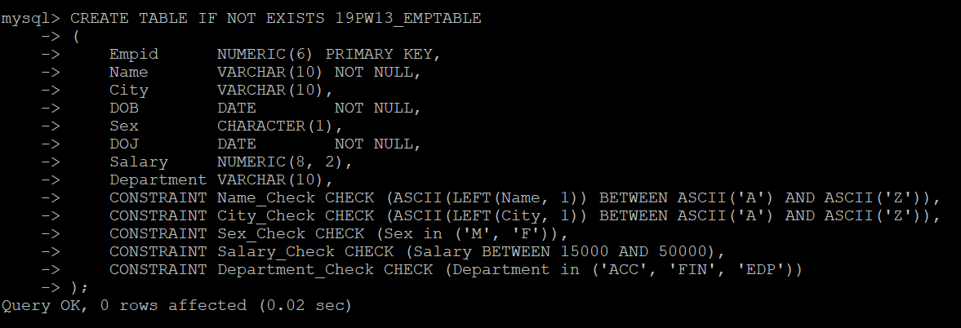

- INSERT the following data into the EMPTABLE table.

Empid | Name | City | DoB | Sex | DoJ | Salary | Department
1001 | Anish | Chennai | 21-apr-66 | M | 10-jun-86 | 17000 | ACC
1002 | Anandi | Ooty | 11-sep-75 | F | 17-jun-97 | 15000 | FIN
1003 | Shiva | Kambam | 07-feb-66 | M | 21-apr-91 | 21000 | EDP
1004 | Deepa | Trichi | 14-feb-67 | M | 21-apr-90 | 12000 | FIN
1005 | Engela |  | 23-mar-70 | F | 21-apr-86 | 32000 | EDP
1006 | Krish | Trichi | 14-jul-70 | F | 21-mar-89 | 15000 | ACC
1007 | Kamal | Ooty | 14-jul-66 | M | 04-mar-90 | 12000 | FIN
1008 | Neela | Madurai | 27-jun-69 | F | 07-apr-90 | 25000 | EDP
1009 | Bala | Coimbatore | 29-oct-62 | M | 21-apr-93 | 20000 | ACC
1010 | Rajesh | Pollachi | 21-apr-66 | M | 12-oct-93 | 17000 | FIN
1011 | Rekha | Coimbatore | 21-apr-70 | F | 14-dec-99 | 20000 | ACC
1012 | Xavier | Madurai | 21-apr-71 | M | 12-mar-97 | 20000 | ACC
1013 | Vinotha | Trichi | 21-apr-72 | F | 21-apr-94 | 17000 | ACC

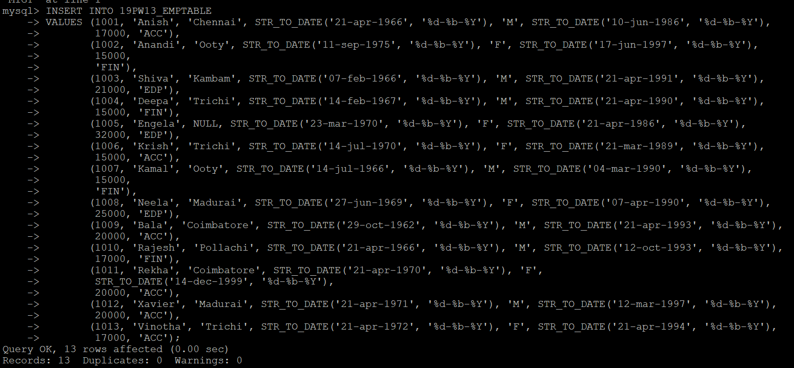

- Answer the following queries by writing SQL statements.

  - Display all the details of all the employees.

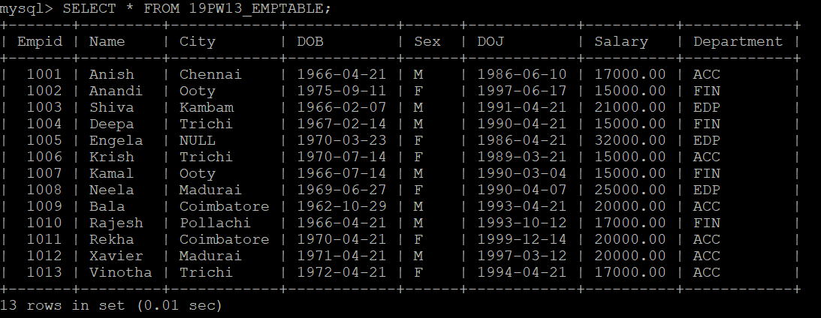

  - Display each employee's id, name, city and salary.

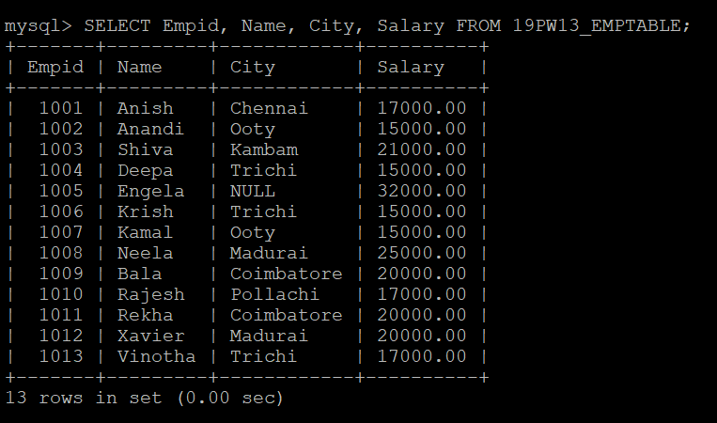

  - Display the employee id of the employee “Bala”.

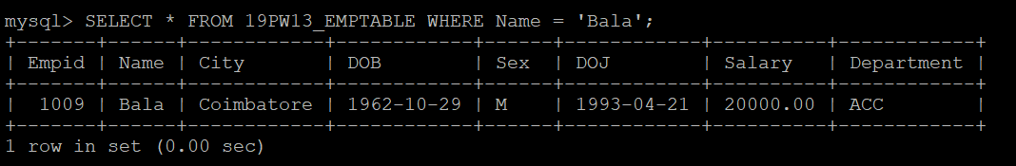

  - List all the details of male employees.

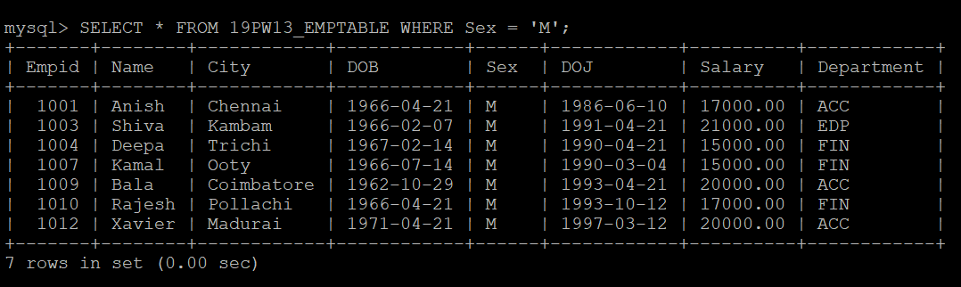

  - Display the details of the employees from Coimbatore.

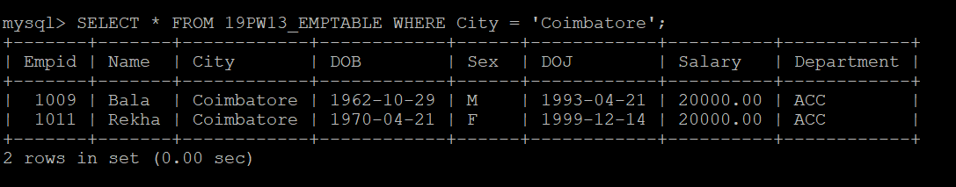

  - Display the details of the employees from Coimbatore, Trichy and Chennai.

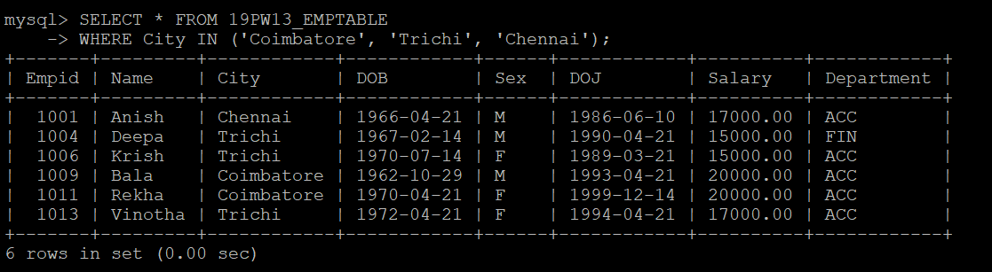

  - Display the name of the employee whose city name is not stored in the EMPTABLE.

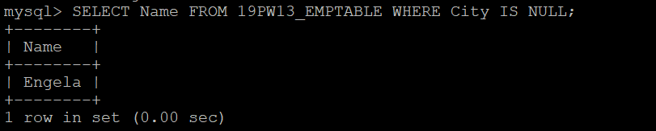

  - Display all the cities of the employees.

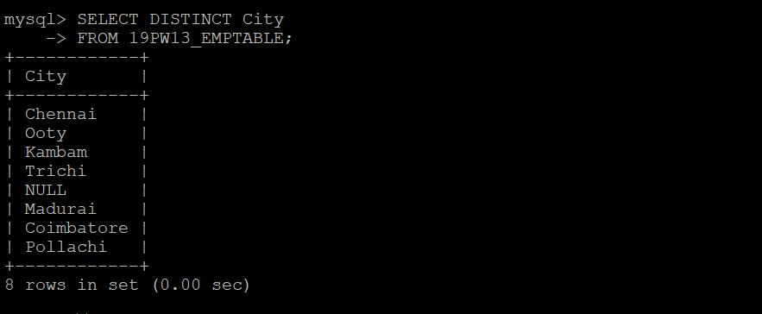

  - Display the employee id with the salary value doubled.

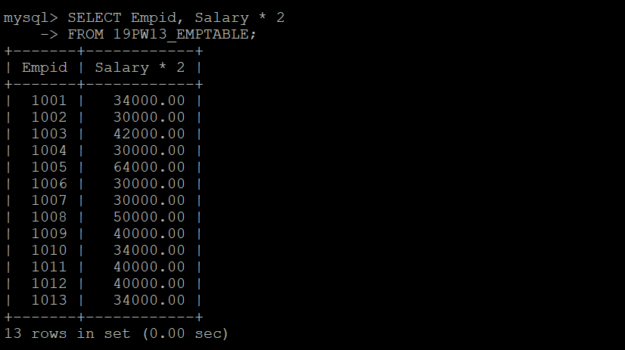
  - Display name, city and department of employees earning more than 50000.



  - Display employee's id, name and salary with a 5% increase under a heading "increased salary".

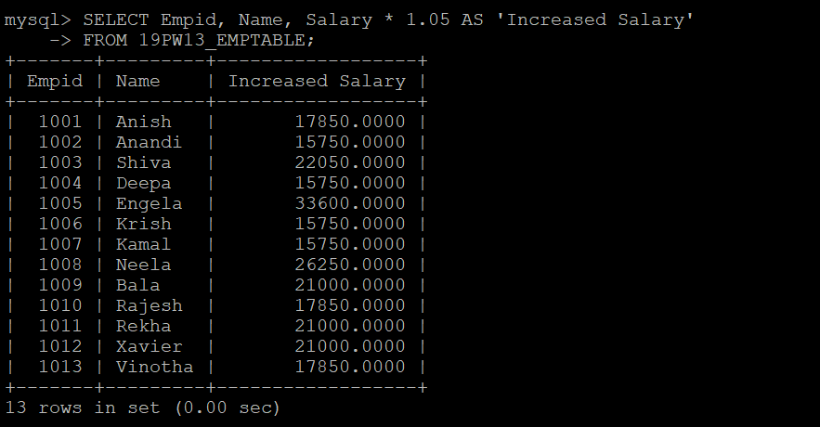

  - Modify the above query so that it lists employees from the highest "increased salary" to the lowest.

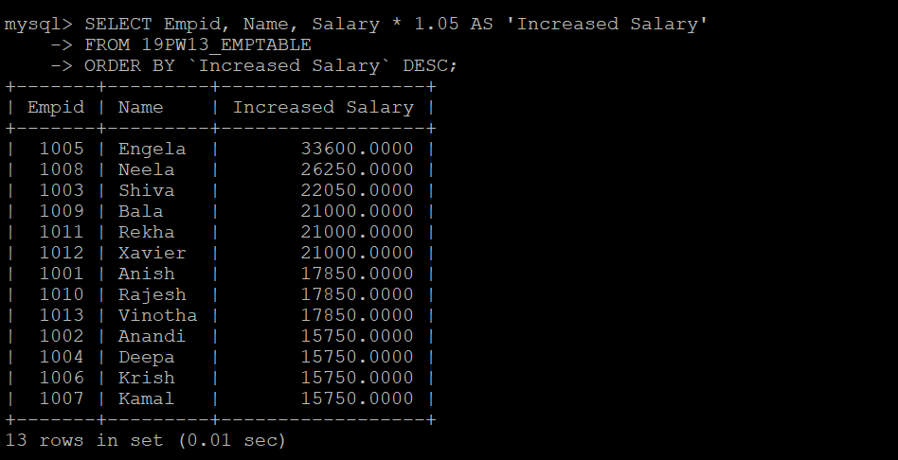

  - Sort and display the details by name in ascending order and salary in descending order.

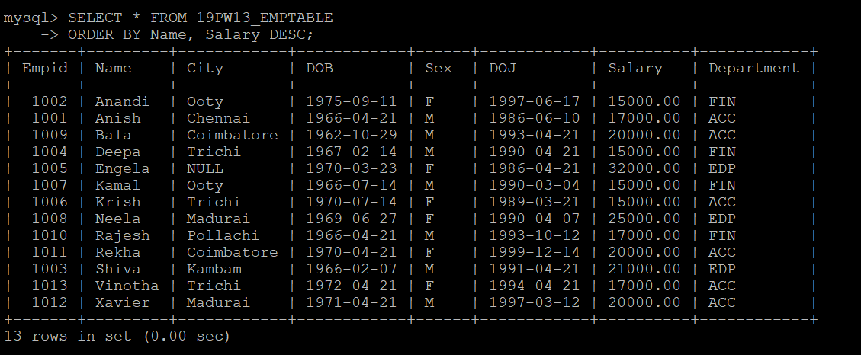

  - Display the number of employees.

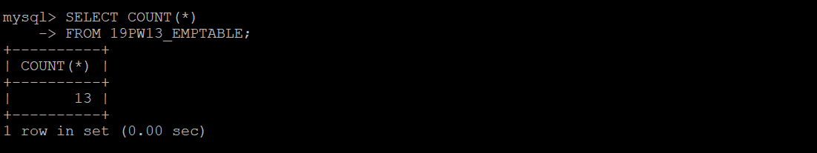

  - Count the number of departments in the EMPTABLE.

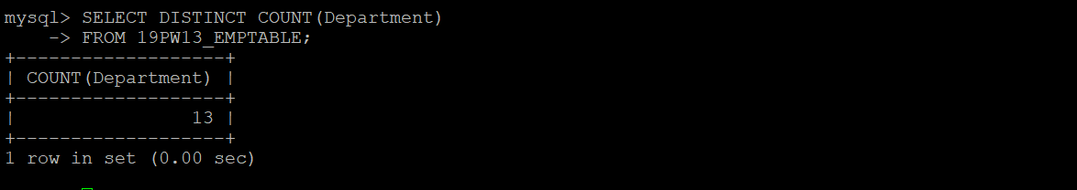

  - Display the number of employees in FIN department.

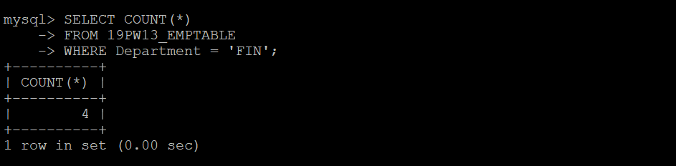

  - Find the number of male employees.

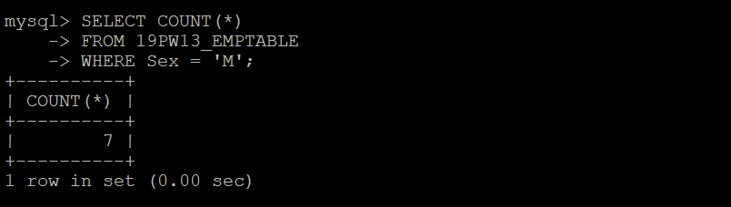

  - Display name of employee earning highest salary.

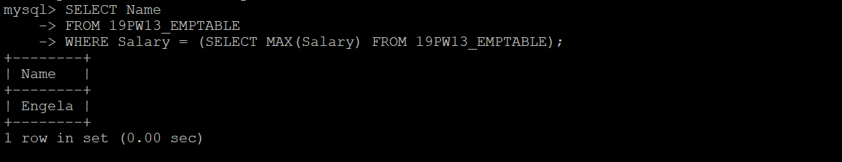

  - Display name of employee earning lowest salary.

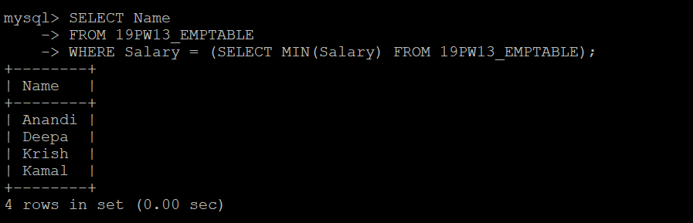

  - Display sum of salary of employees in each department.

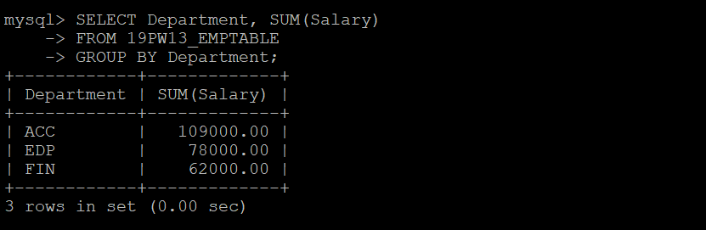

  - List the Empids of all employees except 1002.

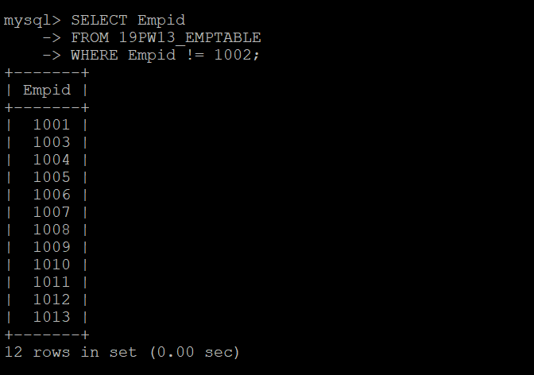

  - Display details of employees whose names start with 'A'.

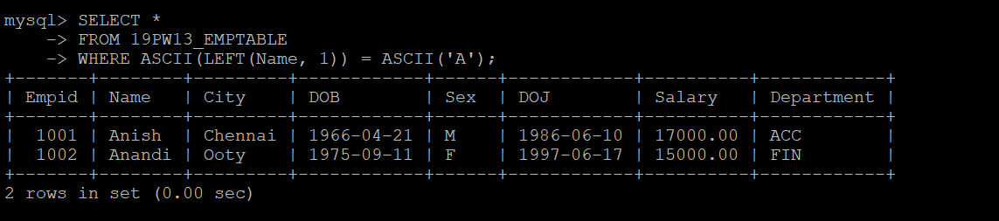

  - Show the details of employees who have born before 01-jan-91.

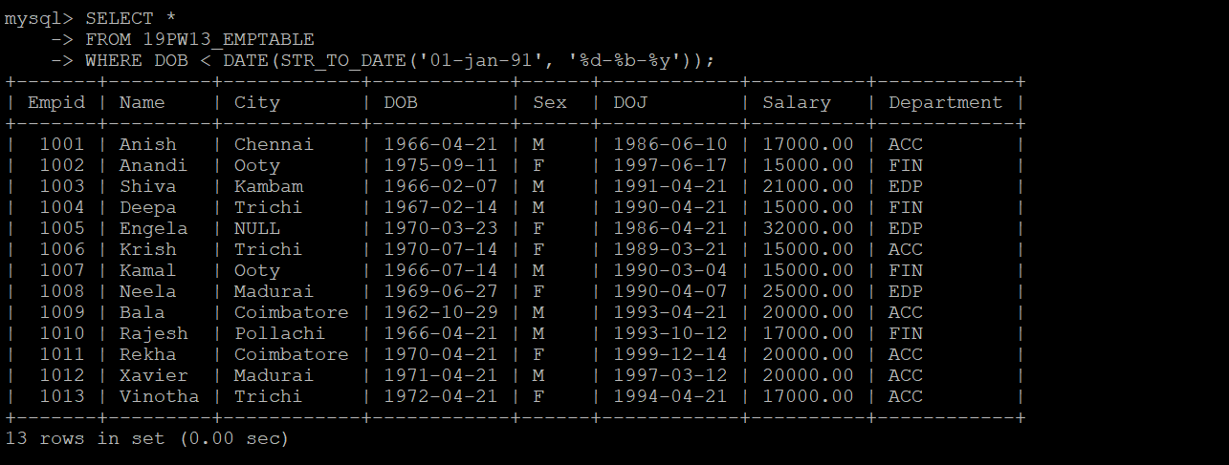

  - Display name of employees whose salaries are between 20000 and 40000.

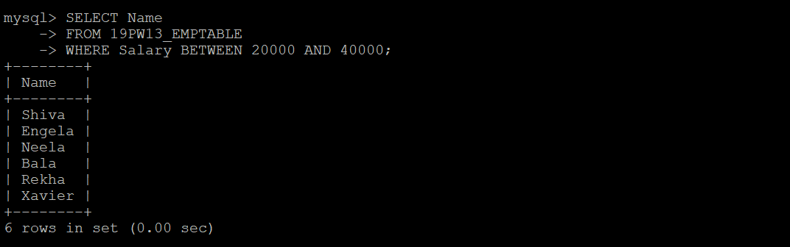

  - Show the details of the employees earning more than 20000.

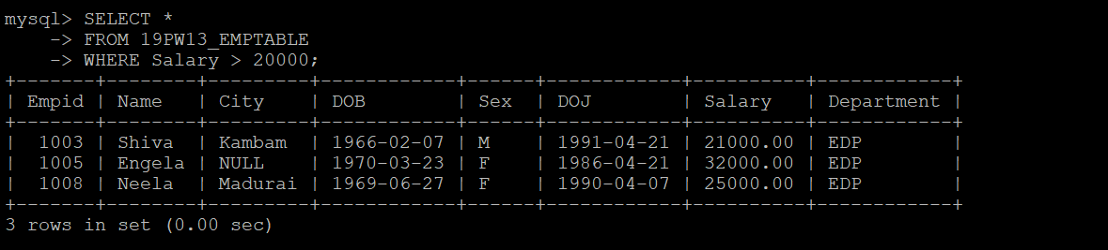

  - Show the details of the employees earning more than 20000 in the department ACC.



  - Show the details of the employees earning more than 20000 in each department.

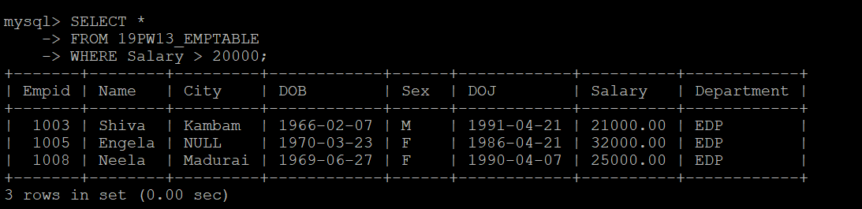

  - Display employees name and the lowest salary earned by them in each department

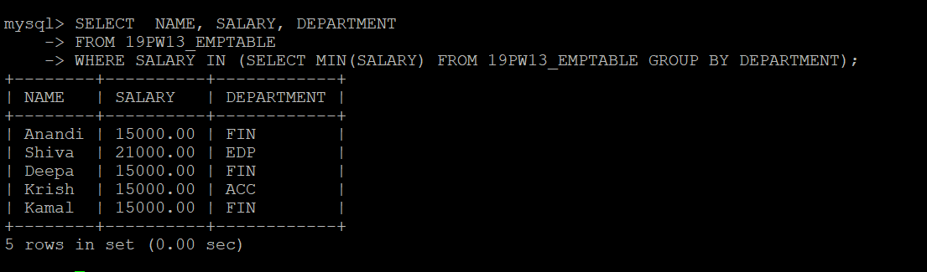

  - Find the number of male employees department wise.

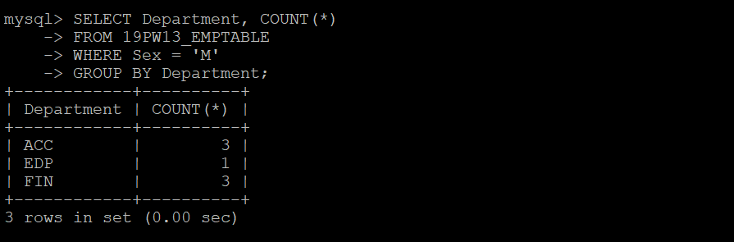

  - Display the minimum, maximum, sum, and average salary for each job type.

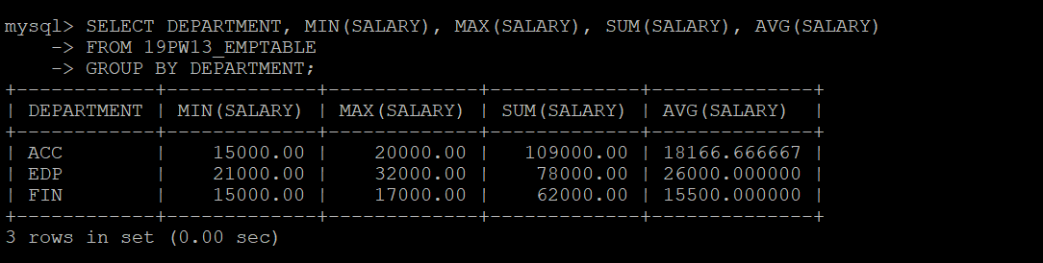

  - Display the experience of each employee in days.

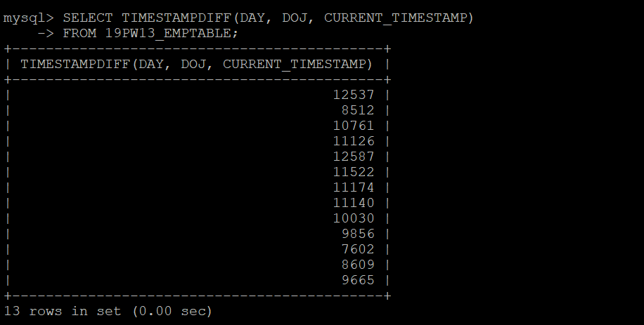

  - Display the experience of each employee in years.

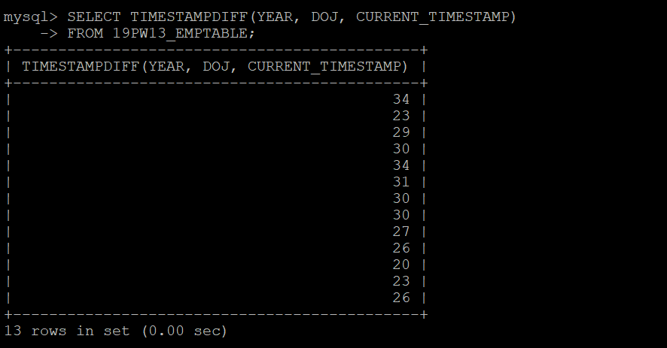

  - Display name and age of all employees.

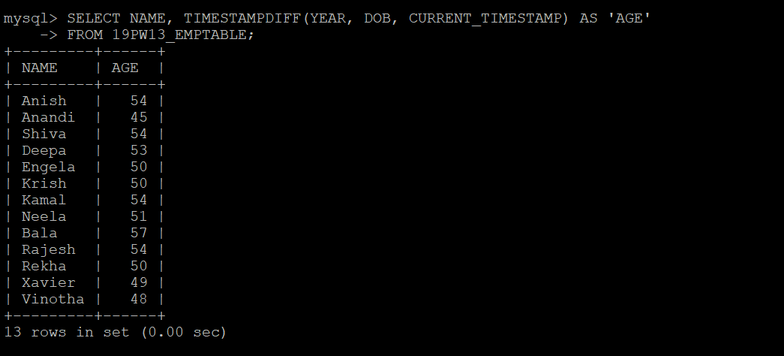

  - Display the employee who is the oldest.



  - How old is the oldest employee?

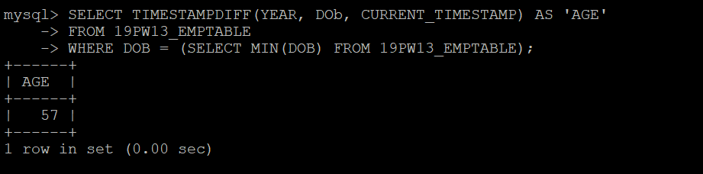

  - Display names, city of employees in alphabetical order.

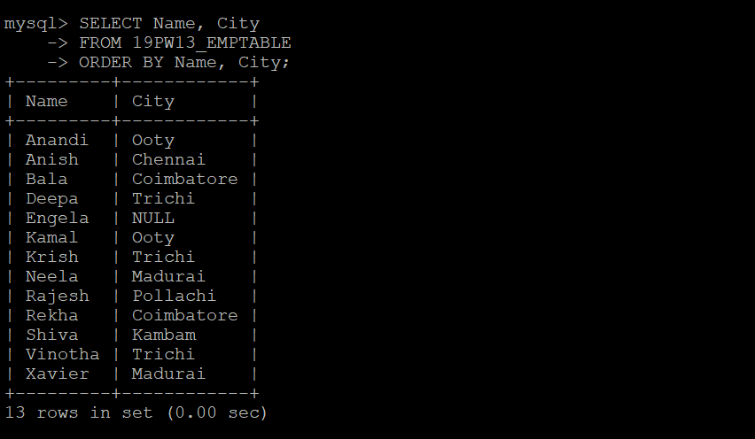

  - Display name, date of birth of employees born in January.



  - Display the number of employees working in each department.

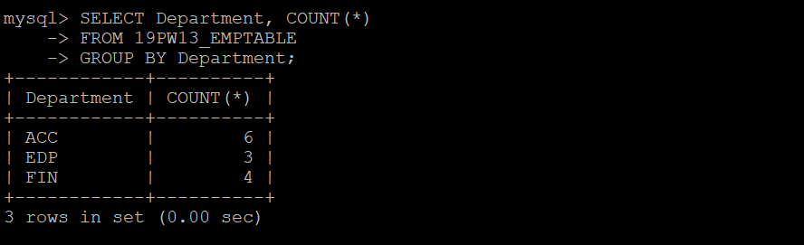

  - What is the average age of the male and female employees?

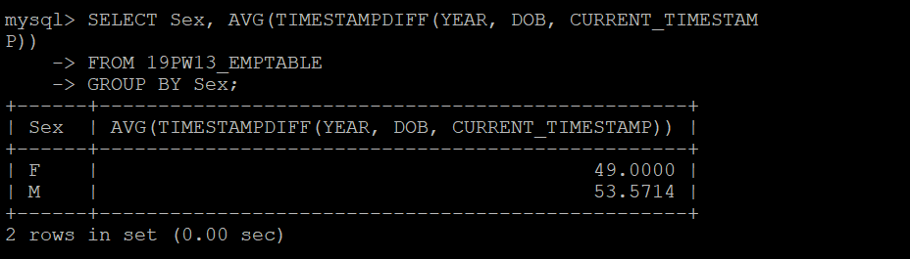

  - Who are the employees who celebrate their birthdays in the current month?

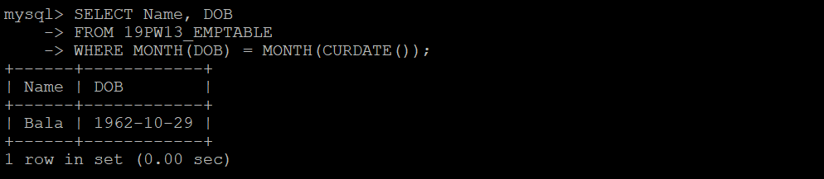

  - What is the average salary?

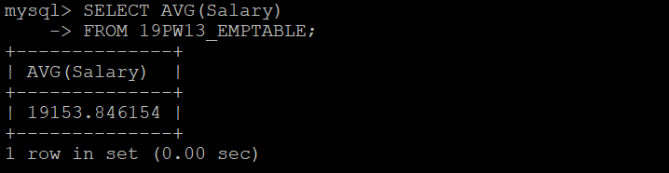

  - What is the average salary in each department?

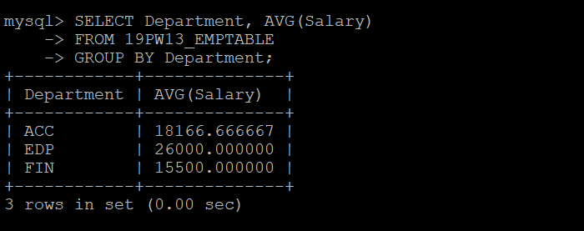

  - Find the sum of salaries in each department
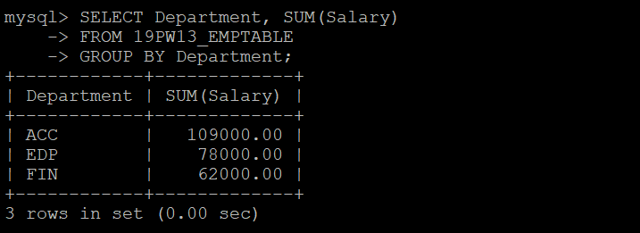

  - How many employees earn more than 30000?
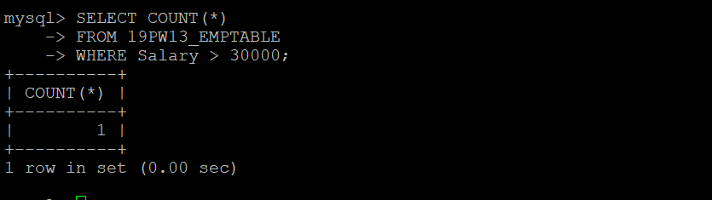

  - Find the maximum salary.
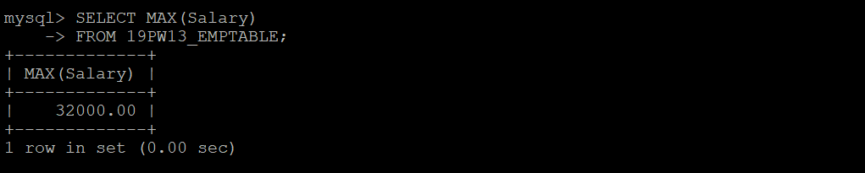

  - Find the maximum salary in each department.
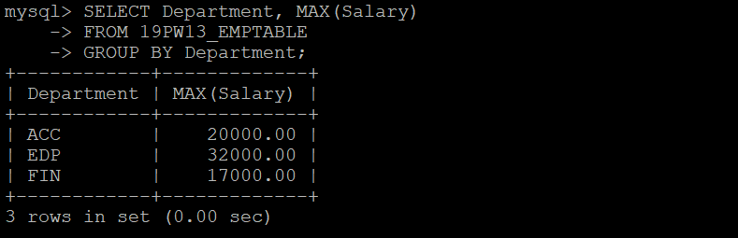

  - How many female employees are coming from Coimbatore?
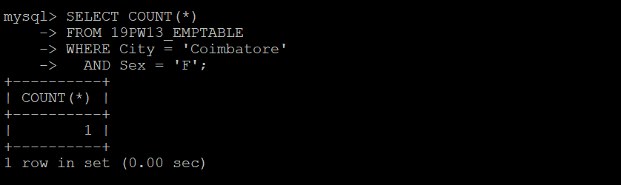

  - Display details of those who weren't born in October and March
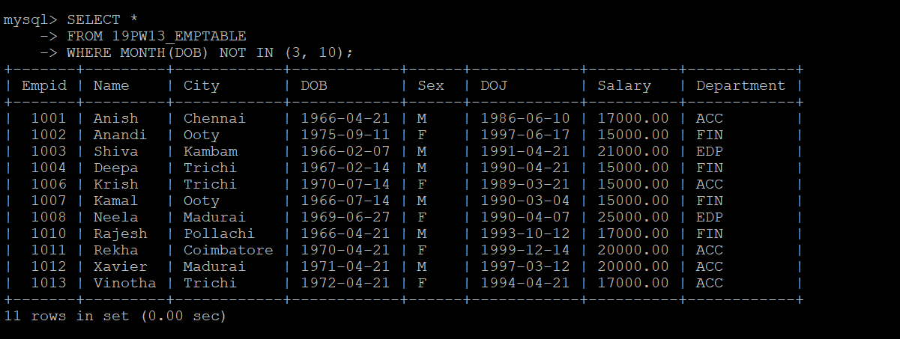

  - Display each department with number of female employees.
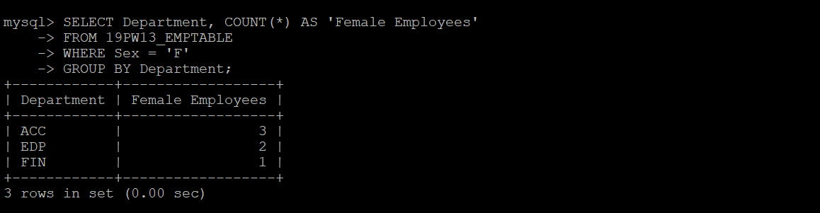

  - Display employee's name, city, and dob in any order.
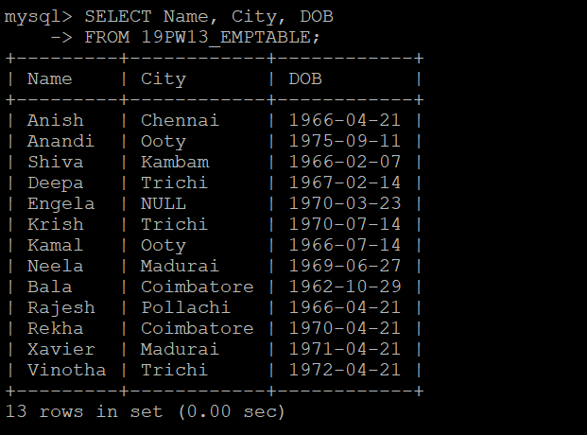

  - Display salary difference between highest and lowest salary.
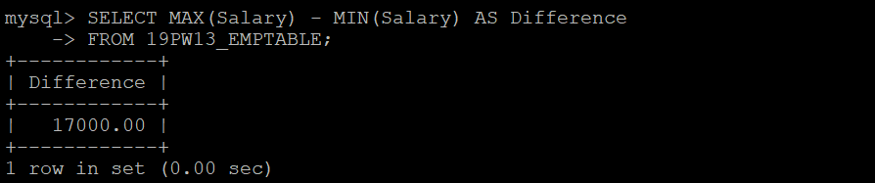

  - Display the department with employees coming from more number of cities.
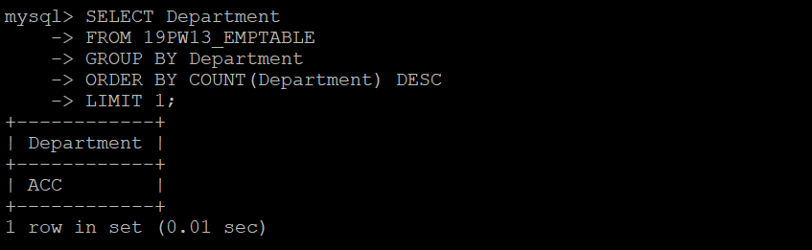

  - Which department has lowest no of employees?
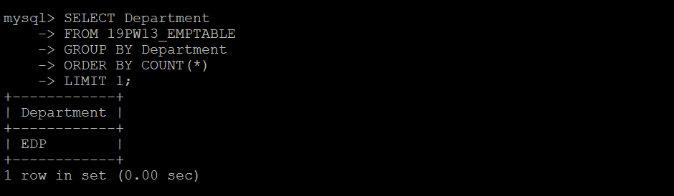

  - Who is the youngest male employee born in 1990?
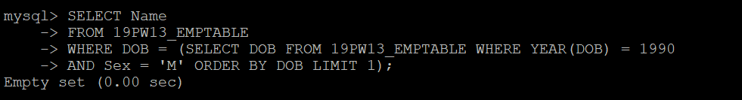

  - Who is the oldest female employee born in 1990?


  - Display names all the employees who are less than 32 years old.


  - List the details of all employees who are younger than the employee with employee id 1007.
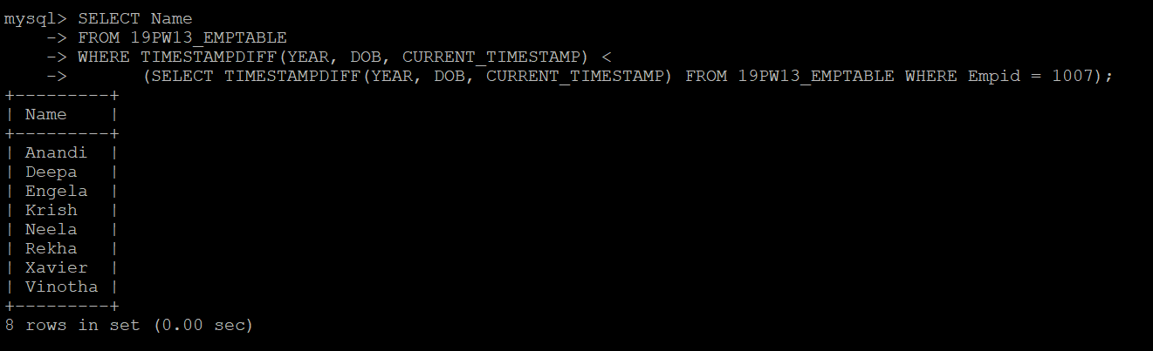

  - In which year was the most number of employees born?
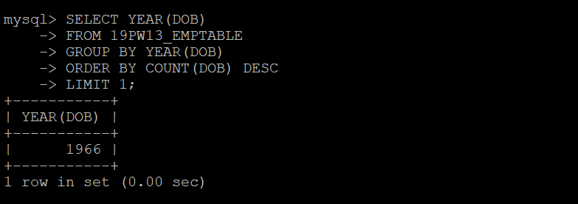

  - In which month was the most number of employees born?
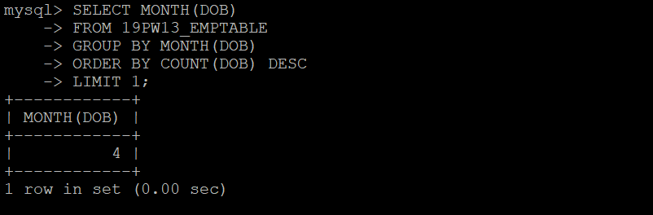

  - Who are the male employees earning below the average salary of female employees?
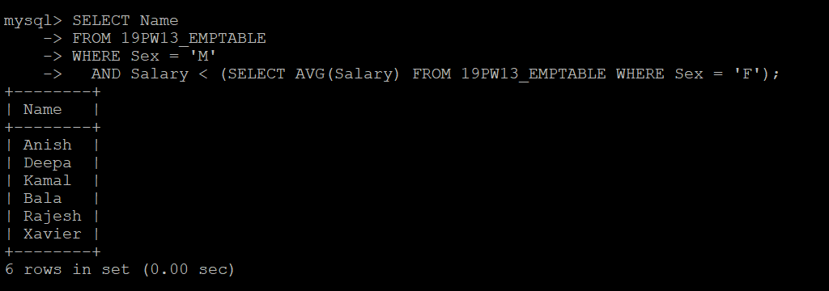

  - Display details of those who are drawing the same salary?
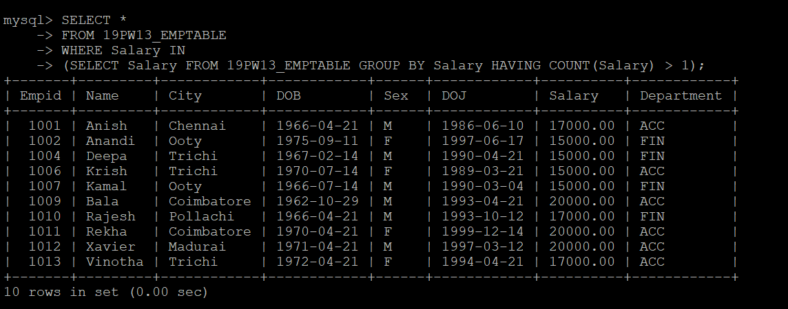

  - How many different departments are there in the table?
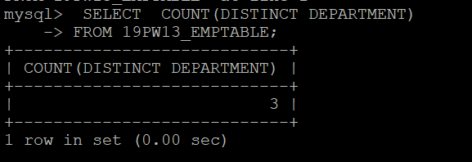

  - Display names of employees whose names contain up to 5 characters.
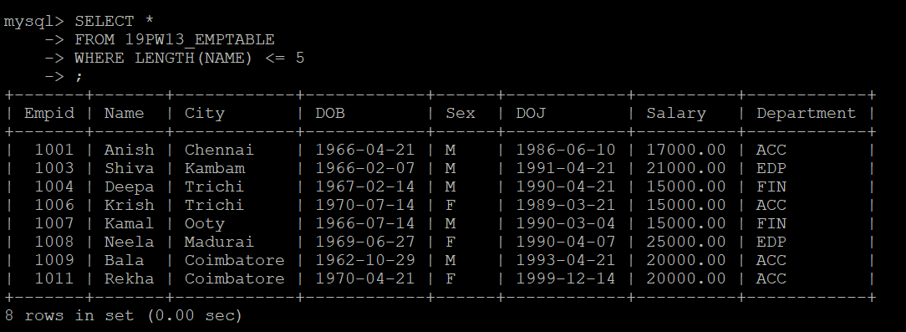

  - Display names of employees whose names contain occurrences of the letter 'e'
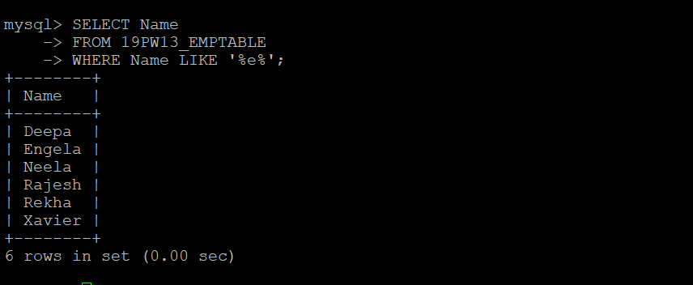

  - Display the details of employees coming from the city ‘Trichy’ and are working in different
departments.
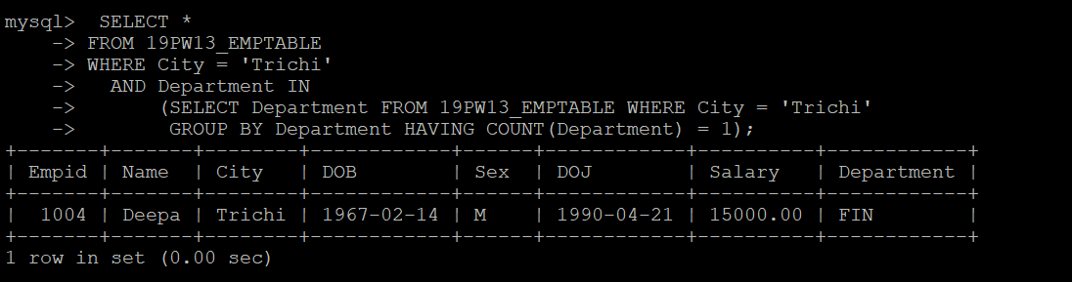

  - Display the details of employees arranged in the order of their cities.
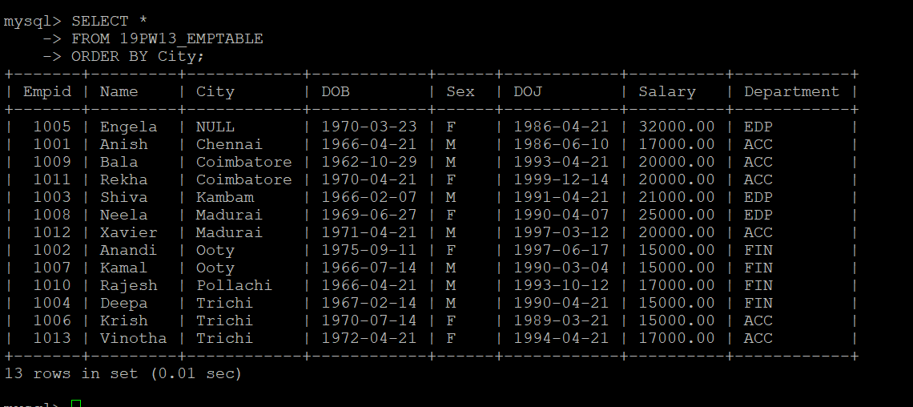

  - Display the city and the number of employees from each city.
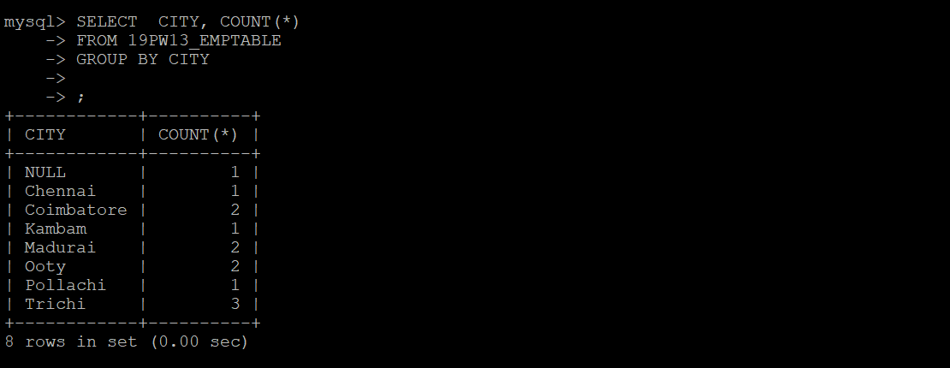

  - Display the employees who are from same city and earn the same salary.
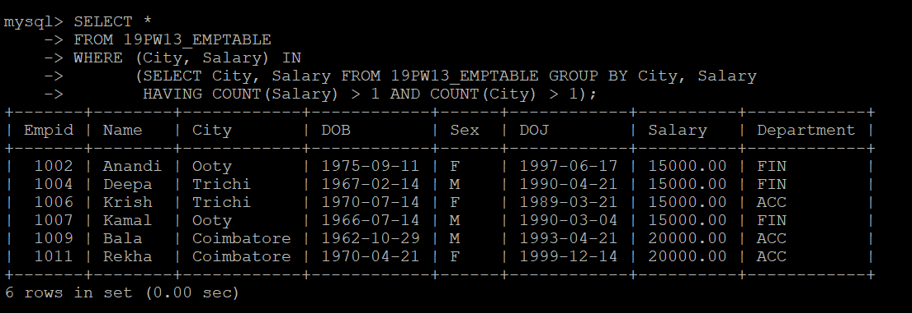

  - Display the department in which there is no employee from Trichy.
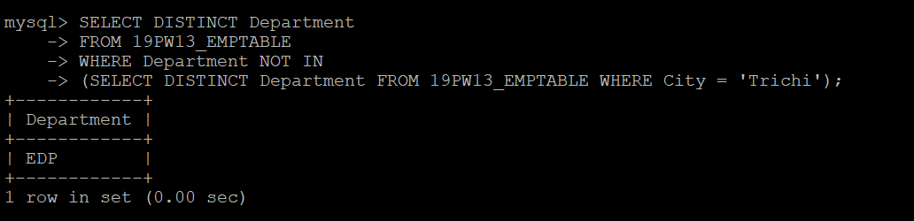

  - Find the employees who work for different departments who earn the same salary.
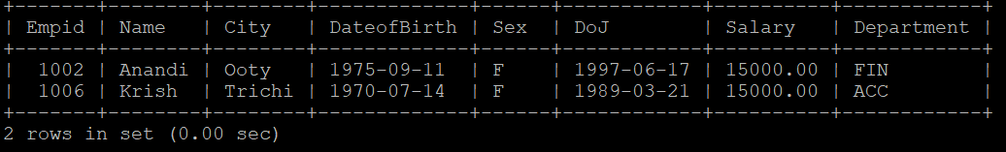

  - Display the female employees who earn the same salary.
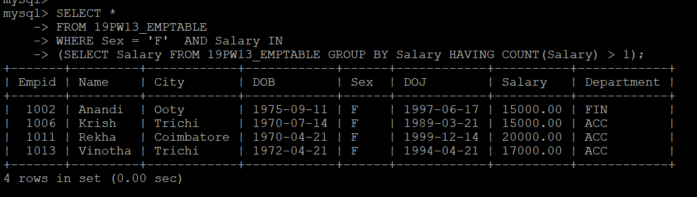

  - Modify the length of the field Name from 10 to 15.


  - Add a new column named age of type numeric with length 3.


  - Update the data into age by computing the value from DoB.
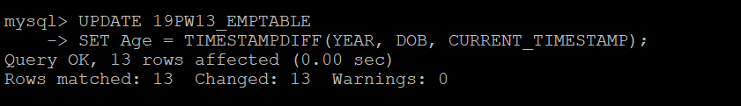

  - Rename the column DoB to DateofBirth.


  - Remove the age column from the table.


  - Display all the employee details in the following format.
Anish of Acc department comes from Chennai

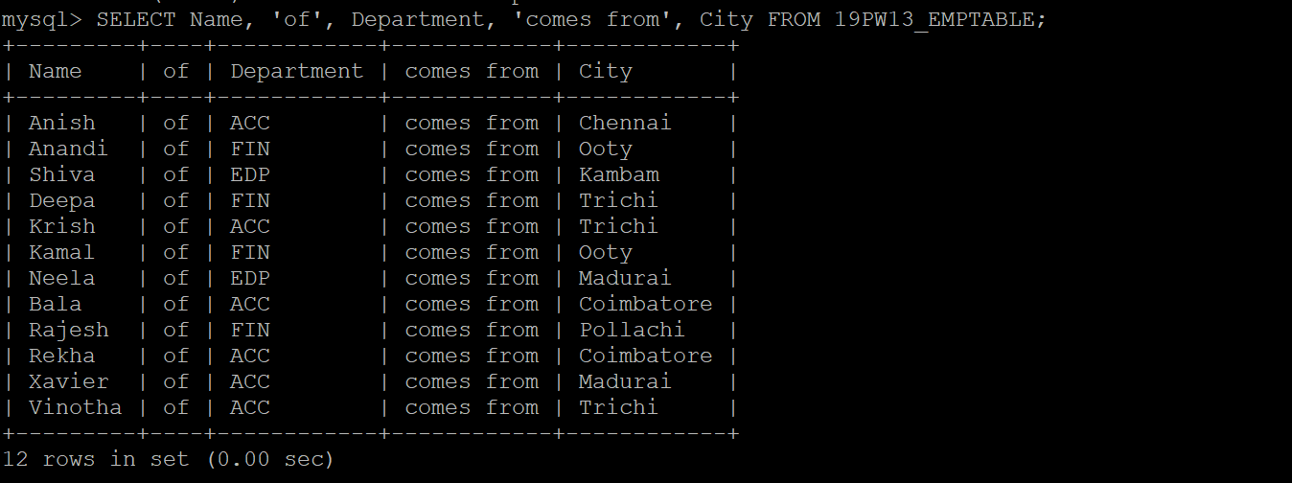

  - What does the following SQL query print?
SELECT Name FROM EMPTABLE WHERE dept = ‘ACC’ ORDER BY 1 DESC;

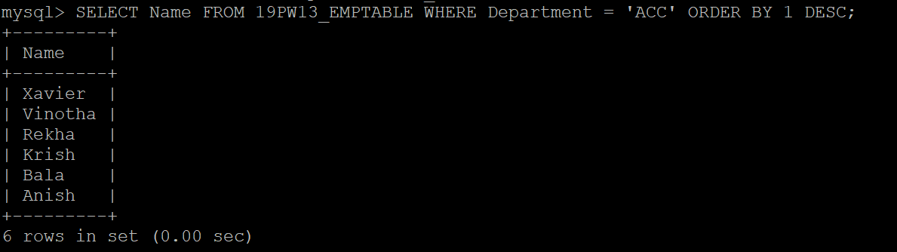

  - Remove the constraint of DoJ.


  - Display the names and cities of all the employees in uppercase.
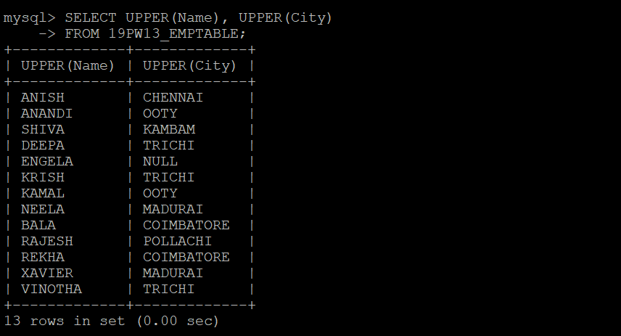

  - In which month was the most number of employees born?
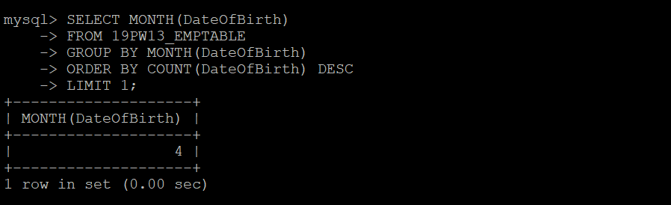

  - Who are the male employees earning below the average salary of the female employees?

  - Who are the female employees earning more than the highest salary of male employee?
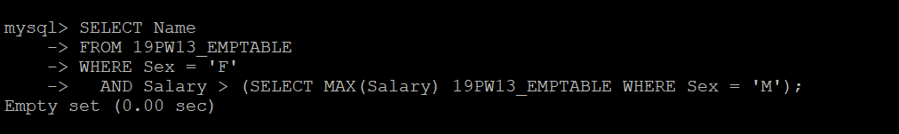

  - Insert a record into EMPTABLE to show violation of primary key constraint.

  - Remove the record of “Engela” from the EMPTABLE.


